3x3’s matrix multiplications

Input data

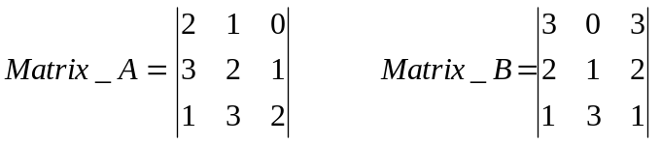 (3x3) by a (3x3) result is a 3x3

This data needs to be entered into the system via a 6-bit input. The matrix data is read from left to right row by row, Matrix_A then Matrix_B. Remember each data bit is two_bits in length. The bit stream will look something as shown below.

Decimal 1 demensional equivalent of the matrices data 2 1 0 3 2 1 1 3 2 3 0 3 2 1 2 1 3 1
Bit stream 100100111001011110110011100110011101
Split the bit stream up into six bit segments starting with the LSB 100100 111001 011110 110011 100110 011101
Convert into their hex equivalent 24 39 1E 33 26 1D

To input the complete set of data 6 ext_clock ticks are required, after the 6 sets of data have been input to the system, a signal START_COM with the system signifies to the rest of the system to act upon the data.

In MATRIX MODE (described on the previous page) 111/ 011 OR HEX(7) / HEX(3) the following matrix product is produced

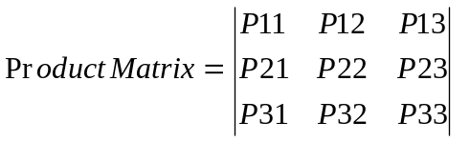

The Calculated matrix product is shown below:-

Calculated Answer:

(2 x 3) + (1 x 2) + (0 x 1) = 8
(3 x 3) + (2 x 2) + (1 x 1) = 14
(1 x 3) + (3 x 2) + (2 x 1) = 11

(2 x 0) + (1 x 1) + (0 x 3) = 1
(3 x 0) + (2 x 1) + (1 x 3) = 5
(1 x 0) + (3 x 1) + (2 x 3) = 9

(2 x 3) + (1 x 2) + (0 x 1) = 8
(3 x 3) + (2 x 2) + (1 x 1) = 14
(1 x 3) + (3 x 2) + (2 x 1) = 11

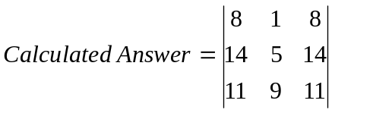

System Answer:

3BFF = 0011 1011 1111 1111 = 08
093A = 0000 1001 0011 1010 = 14
0912 = 0000 1001 0001 0010 = 11

3B92 = 0011 1011 1001 0010 = 01
3BEB = 0011 1011 1110 1011 = 05
3BFB = 0011 1011 1111 1011 = 09

3BFF = 0011 1011 1111 1111 = 08
093A = 0000 1001 0011 1010 = 14
0912 = 0000 1001 0001 0010 = 11

3B92 = 0011 1011 1001 0010 = 01
OR
097F = 0000 1001 0111 1111 = 18

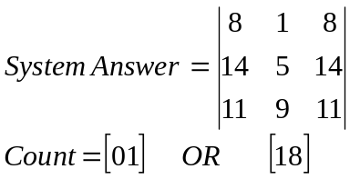

(2x3) by a (3x3) matrix multiplications

Input data

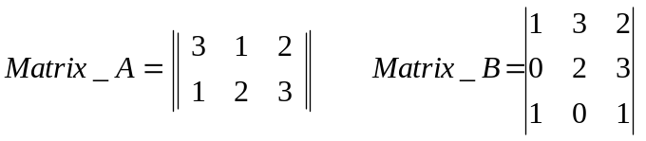 (2x3) by a (3x3) result is a 2x3

This data needs to be entered into the system via a 6-bit input. The matrix data is read from left to right row by row, Matrix_A then Matrix_B. Remember each data bit is two_bits in length. The bit stream will look something as shown below.

Decimal 1 demensional equivalent of the matrices data 3 1 2 1 2 3 0 0 0 1 3 2 0 2 3 1 0 1
Bit stream 110110011011000000011110001011010001
Split the bit stream up into three bit segments starting with the LSB 110110 011011 000000 011110 001011 010001
Convert into their hex equivalent 36 1B 0 1E 0B 11

To input the complete set of data 6 ext_clock ticks are required, after the 6 sets of data have been input to the system, a signal START_COM with the system signifies to the rest of the system to act upon the data.

In MATRIX MODE (described on the previous page) 110 / 010 OR HEX(6) / HEX(2) the following matrix product is produced

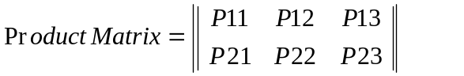

The Calculated matrix product is shown below:-

Calculated Answer:

(3 x 1) + (1 x 0) + (2 x 1) = 5
(1 x 1) + (2 x 0) + (3 x 1) = 4

(3 x 3) + (1 x 2) + (2 x 0) = 11
(1 x 3) + (2 x 2) + (3 x 0) = 7

(3 x 2) + (1 x 3) + (2 x 1) = 11
(1 x 2) + (2 x 3) + (3 x 1) = 11

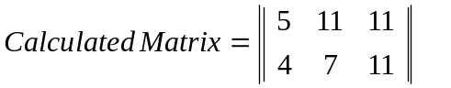

System Answer:

3BEB = 0011 1011 1110 1011 = 05
3BBA = 0011 1011 1011 1010 = 04

0912 = 0000 1001 0001 0010 = 11
3BD2 = 0011 1011 1101 0010 = 07

0912 = 0000 1001 0001 0010 = 11
0912 = 0000 1001 0001 0010 = 11

3B92 = 0011 1011 1001 0010 = 01
OR
096B = 0000 1001 0110 1011 = 15

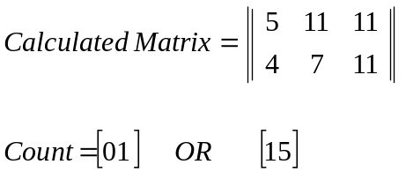

(2x3) by a (3x3) matrix multiplications

Input data

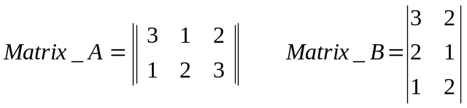 (2x3) by a (3x2) result is a 2x2

This data needs to be entered into the system via a 6-bit input. The matrix data is read from left to right row by row, Matrix_A then Matrix_B. Remember each data bit is two_bits in length. The bit stream will look something as shown below.

Decimal 1 demensional equivalent of the matrices data 120321000320210120
Bit stream 011000111001000000111000100100011000
Split the bit stream up into three bit segments starting with the LSB 011000 111001 000000 111000 100100 011000
Convert into their hex equivalent 18 39 00 38 24 18

To input the complete set of data 6 ext_clock ticks are required, after the 6 sets of data have been input to the system, a signal START_COM with the system signifies to the rest of the system to act upon the data.

In MATRIX MODE (described on the previous page) 101 / 001 OR HEX(5) / HEX(1) the following matrix product is produced



The Calculated matrix product is shown below:-

Calculated Answer:

(1 x 3) + (2 x 2) + (0 x 1) = 7
(3 x 3) + (2 x 2) + (1 x 1) = 14

(3 x 2) + (2 x 1) + (0 x 2) = 4
(1 x 2) + (2 x 1) + (1 x 2) = 10
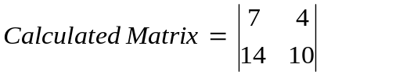

System Answer:

3BD2 = 0011 1011 1101 0010 = 07
093A = 0000 1001 0011 1010 = 14
3BBA = 0011 1011 1011 1010 = 04
0977 = 0000 1001 0111 0111 = 10

3B92 = 0011 1011 1001 0010 = 01
OR
095D = 0000 1001 0101 1101 = 12

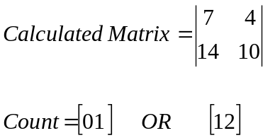

(2x2) by a (2x2) matrix multiplications

Input data

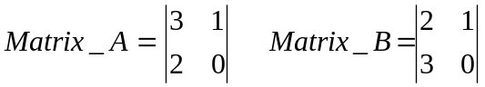 (2x2) by a (2x2) result is a 2x2

This data needs to be entered into the system via a 6-bit input. The matrix data is read from left to right row by row, Matrix_A then Matrix_B. Remember each data bit is two_bits in length. The bit stream will look something as shown below.

Decimal 1 demensional equivalent of the matrices data 310200000210300000
Bit stream 110100100000000000100100110000000000
Split the bit stream up into three bit segments starting with the LSB 110100 100000 000000 100100 110000 000000
Convert into their hex equivalent 34 20 00 24 30 00

To input the complete set of data 6 ext_clock ticks are required, after the 6 sets of data have been input to the system, a signal START_COM with the system signifies to the rest of the system to act upon the data.

In MATRIX MODE (described on the previous page) 100 / 000 OR HEX(4) / HEX(0) the following matrix product is produced

The Calculated matrix product is shown below:-

Calculated Answer:

(3 x 2) + (1 x 3) = 9
(2 x 2) + (0 x 3) = 4

(3 x 1) + (1 x 0) = 3
(2 x 1) + (0 x 0) = 2
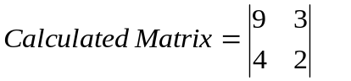

System Answer:

3BFB = 0011 1011 1111 1011 = 09
3BBA = 0011 1011 1011 1010 = 04

3BDB = 0011 1011 1101 1011 = 03
3BDD = 0011 1011 1101 1101 = 02

3B92 = 0011 1011 1001 0010 = 01
OR
3BFF = 0011 1011 1111 1111 = 12

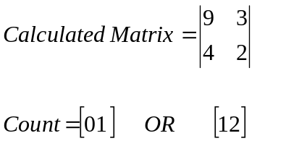

Pod_A_Lyzer Output

1 1 1 1 1 0 1, 1 1 1 0 1 1 1
0 1 0 1 1 0 0, 0 1 0 0 1 0 0
0 0 0 0 0 0 0, 0 0 0 0 0 0 0
0 1 0 0 1 0 0, 0 1 0 0 1 0 0
0 1 0 0 1 0 0, 1 1 1 0 1 1 1
1 1 0 1 0 0 1, 1 1 1 0 1 1 1
1 1 0 1 1 0 1, 1 1 1 0 1 1 1

1 1 1 1 1 0 1, 1 1 1 0 1 1 1
0 1 0 1 1 0 0, 0 1 0 0 1 0 0
0 0 0 0 0 0 0, 0 0 0 0 0 0 0
0 1 0 0 1 0 0, 0 1 0 0 1 0 0
0 1 0 0 1 0 0, 1 1 1 0 1 1 1

